MIDSUMMA FESTIVAL: CARNIVAL – SOCIAL STORY

21 JAN 2024 – Alexandra Gardens, Melbourne CBD, 11am – 10pm

Misumma.org.au/carnival

Midsumma Carnival is an annual queer-day-out in the park to kick start Midsumma Festival's 22 days of celebration. Carnival takes over Alexandra Gardens in Melbourne’s CBD and is a full day of performances, stalls, food, and interactive activities.

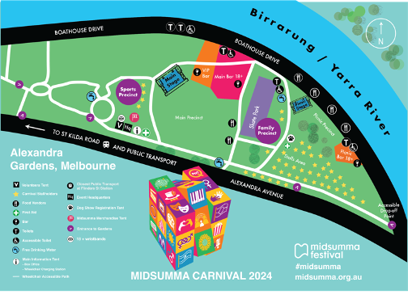

Showcasing our local and international artists and performers, with endless things to see, do, and eat your way through, Midsumma Carnival is an iconic full-day outdoor event for everyone to enjoy!
Image Description: An illustrated map of Midsumma Carnival. Download PDF map here.
On the day of the Midsumma Carnival, if you need help at any time, you can find a staff member or volunteer who are all wearing black shirts with the Midsumma Festival 2024 logo on it and STAFF or VOLUNTEER on the back.
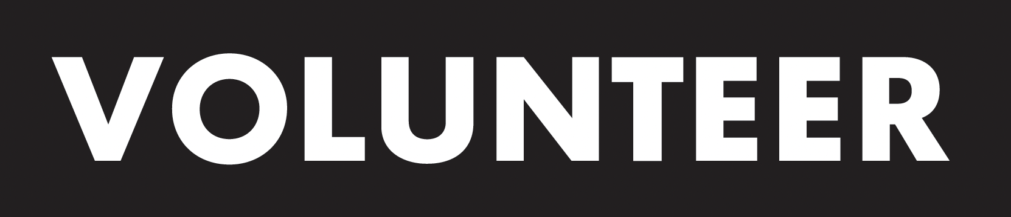
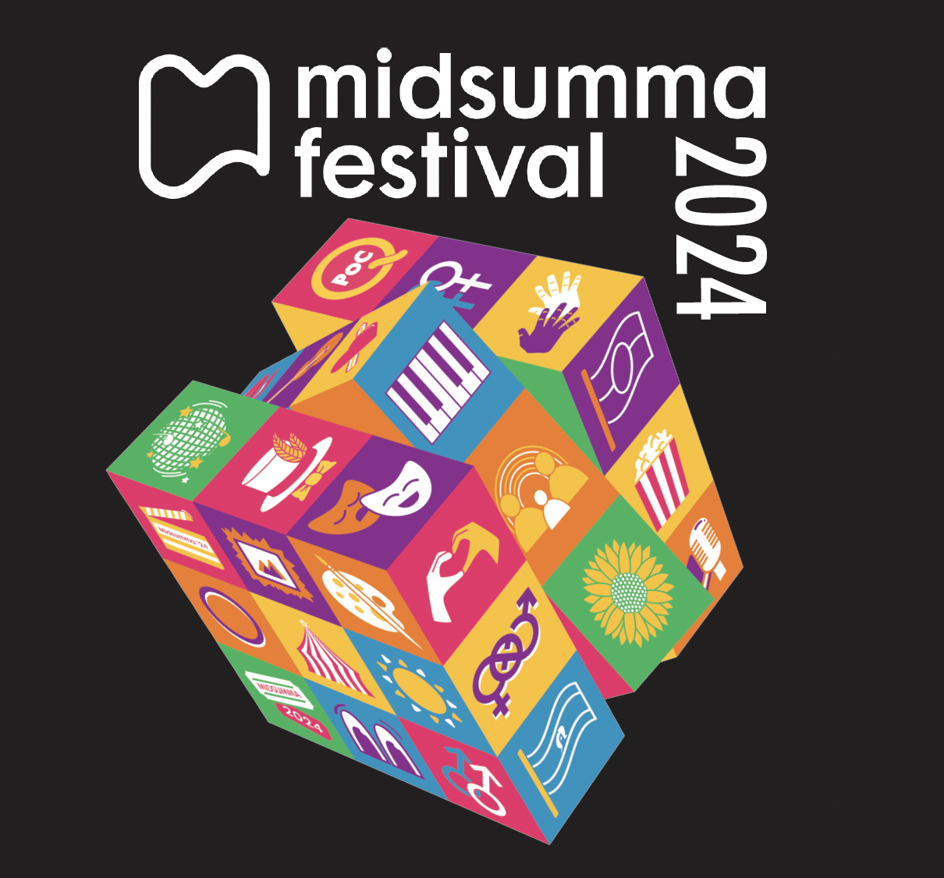
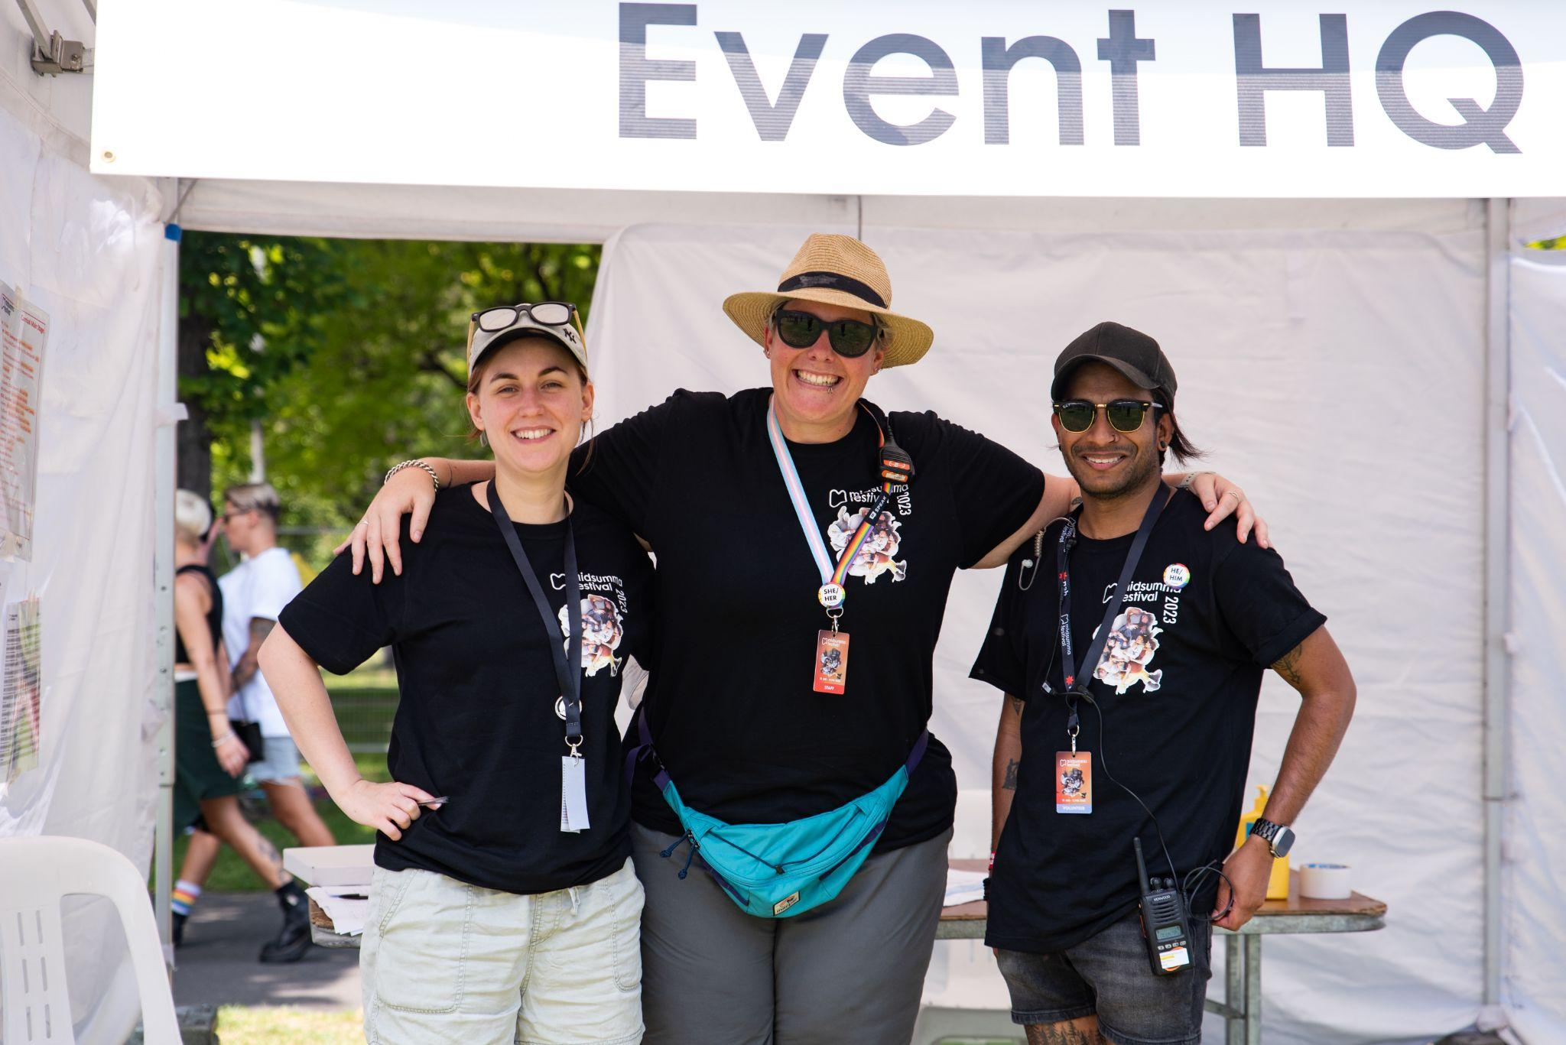
Image Description from L to R: a black box showing a white Midsumma Festival 2024 logo, and a Rubiks cube with different illustrations of art and community representation. Three Midsumma representatives standing together and smiling at the camera.
The Midsumma Carnival Accessible Drop Off Point is on the corner of Alexandra Avenue and Boathouse Drive. There is a white marquee here on the corner which will be staffed. There will be seating and a ramp from the street to the kerb. Please note there is no parking on site, and the closest accessible car parks are at Arts Centre Melbourne and Federation Square.
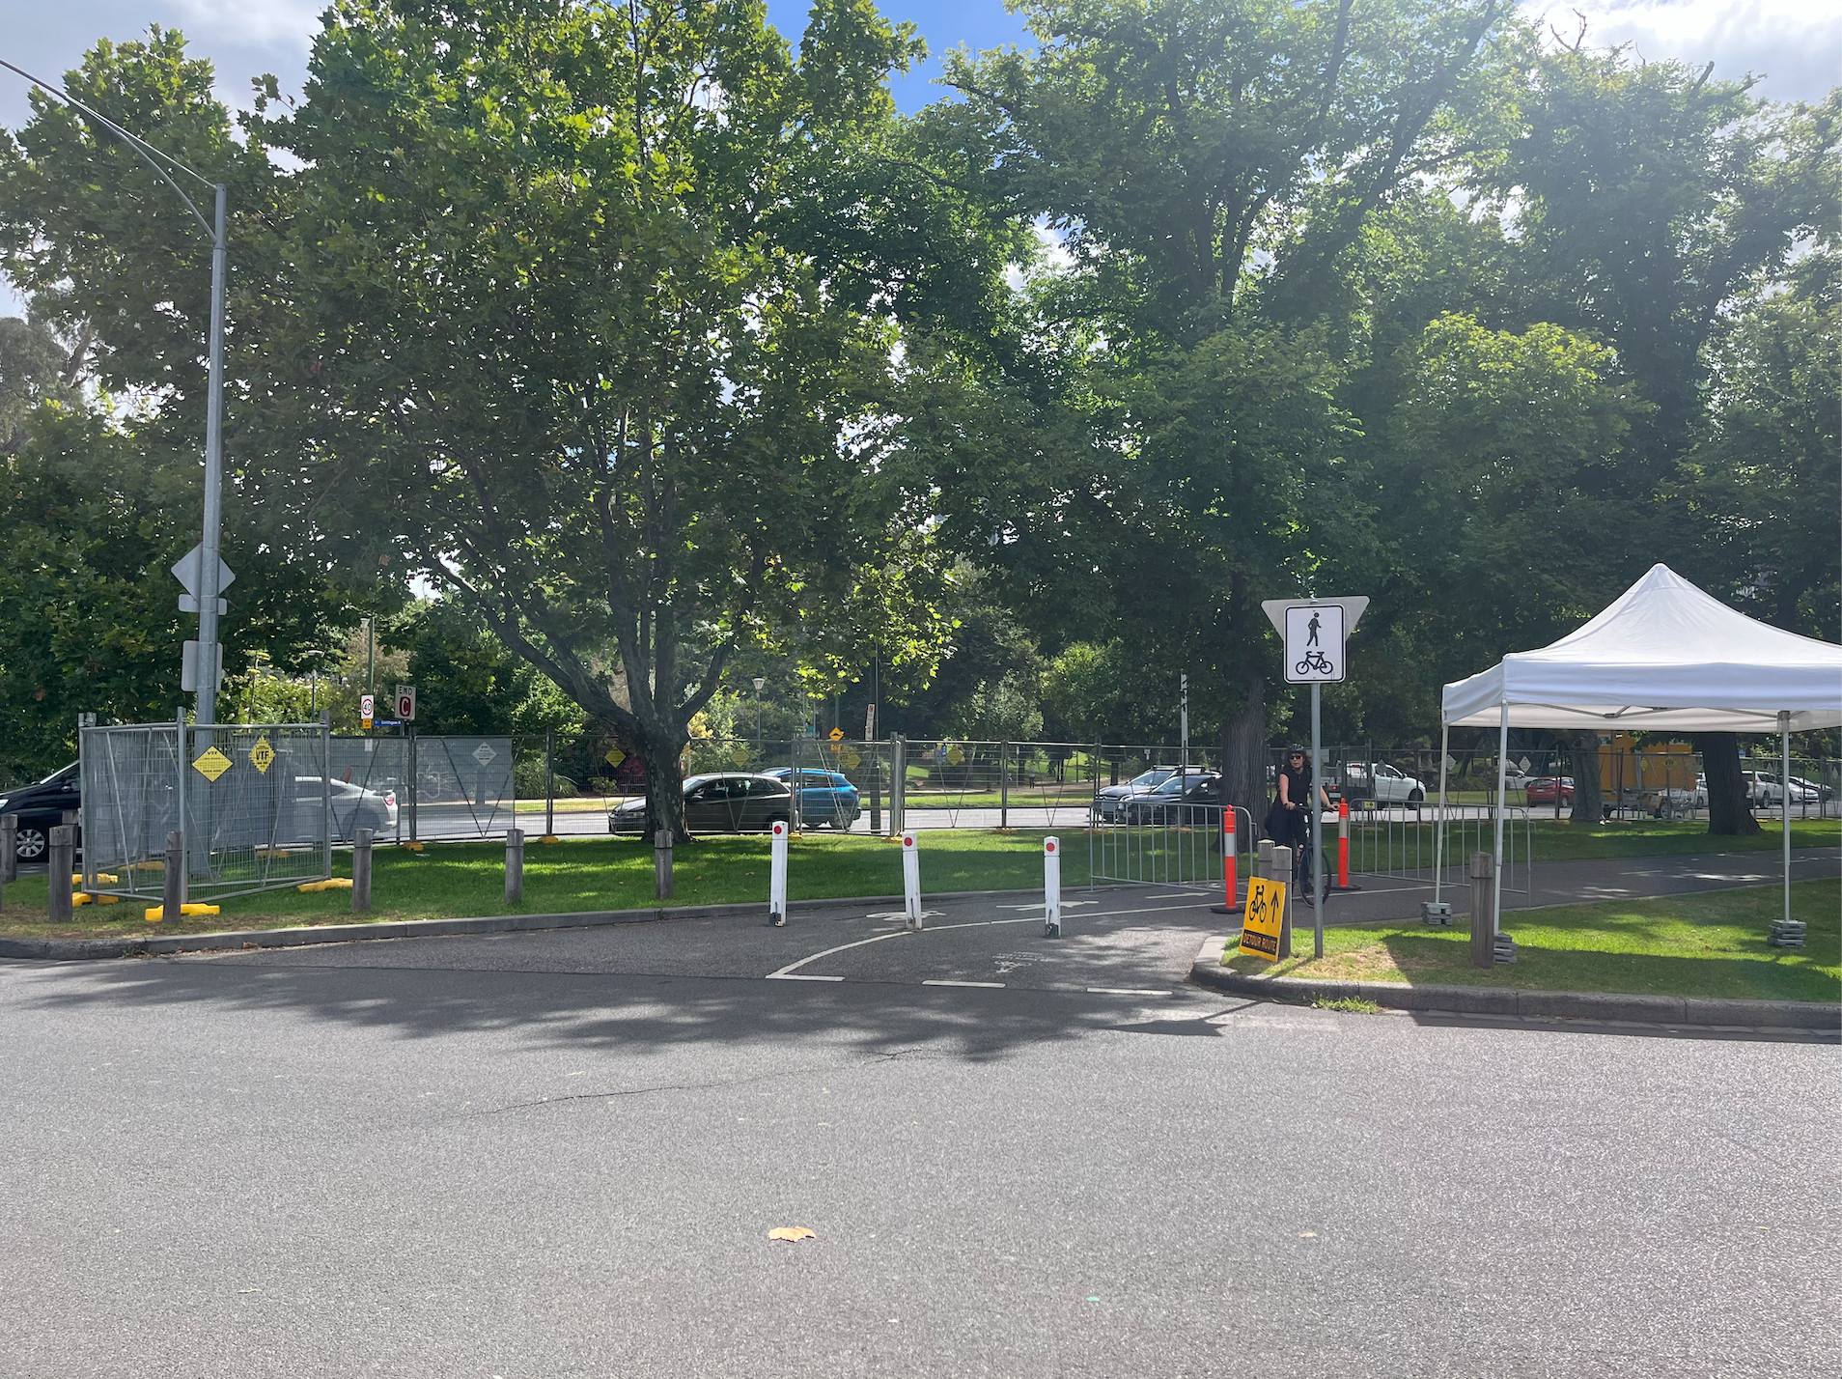
Image Description: A road, with a white marquee on the right hand side. There are a lot of trees, and busy traffic from Alexandra Parade in the background.
The other entrance to Midsumma Carnival is anywhere along the footpath along Alexandra Parade.
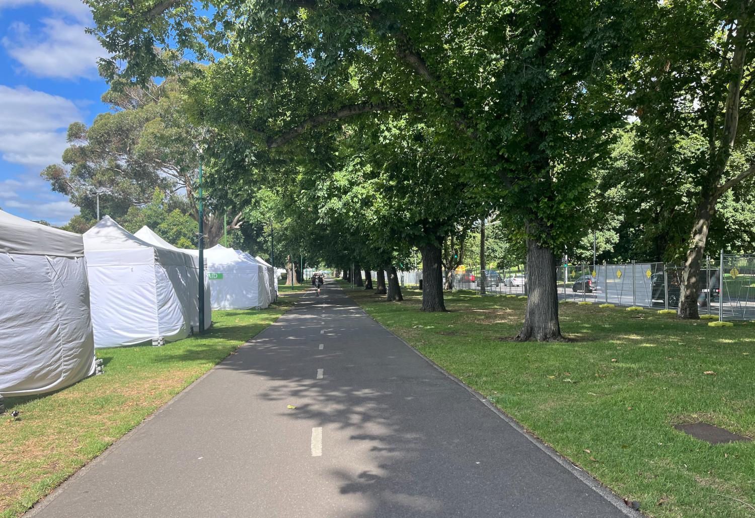
Image Description: A large footpath with white marquees on one side and a lot of trees on the other side.

The Main Stage is located in the centre of the precinct.
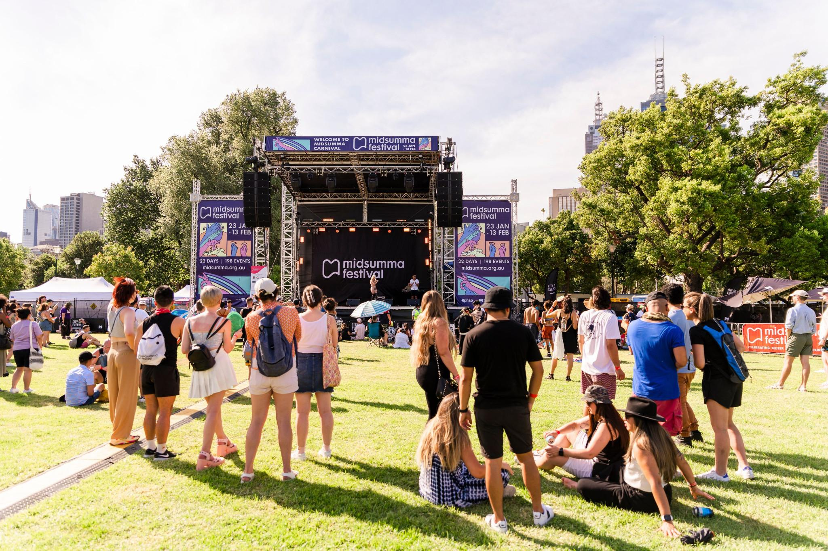
Image Description: A large outdoor stage surrounded by trees and grass, with lots of people in groups watching it.
Image credit: Nikki Russian - Midsumma Carnival 2022
Midsumma Carnival is quieter in the morning with less people in the area. It usually gets crowded in the afternoon or evening with lots of people arriving in the late afternoon.

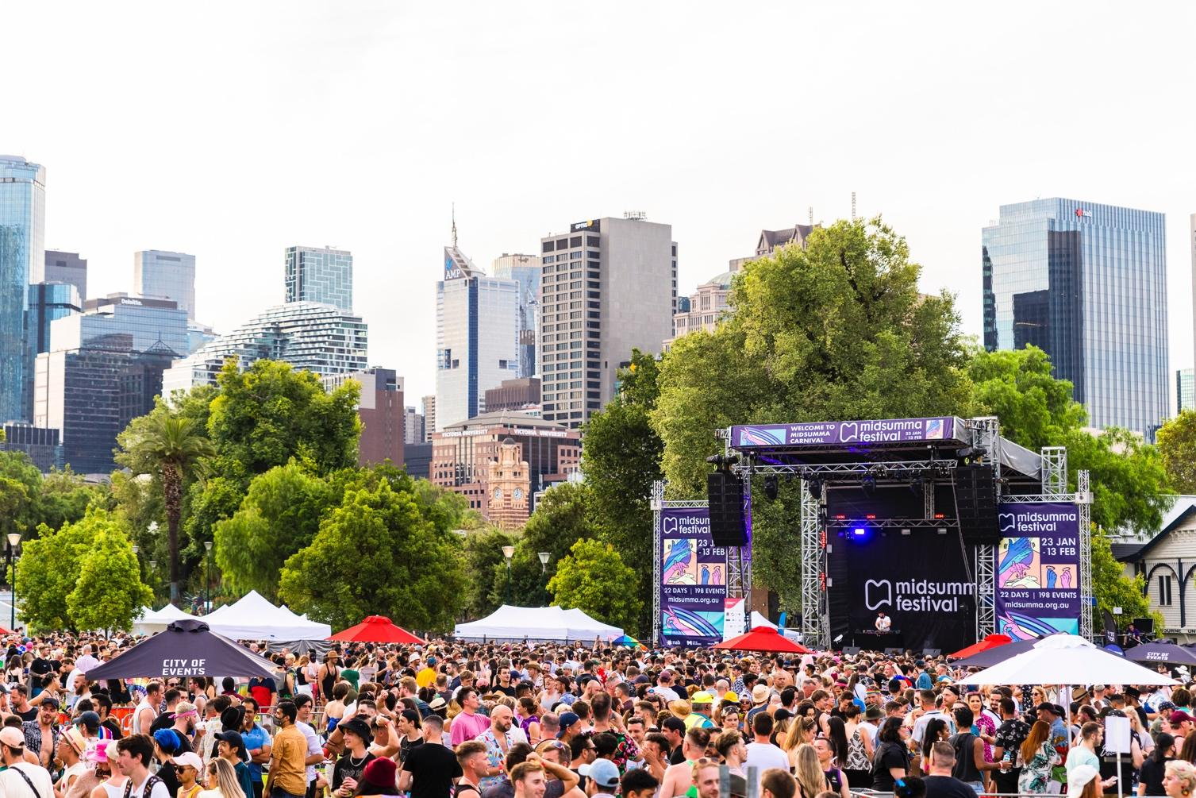

Image Description: A large outdoor stage surrounded by trees and grass, with lots of people in groups watching it and socialising with each other.
Image credit: Nikki Russian – Midsumma Carnival 2022

The First Aid Tent is located at the back of the field where the Main Stage is. The Information Tent is also located here. We will have staff here if you need help at any time.

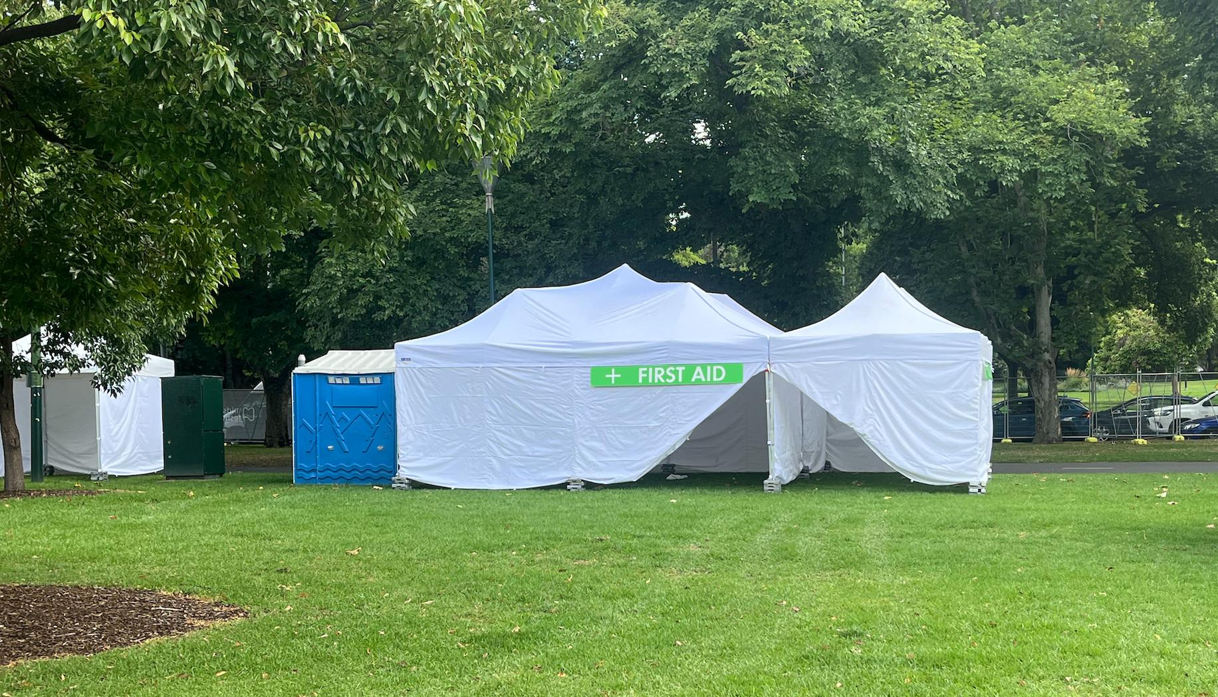

Image Description: White Marquee with large green FIRST AID sign and a portable accessible toilet.

Portable toilets are scattered around the site. They are blue and the larger ones are accessible toilets.

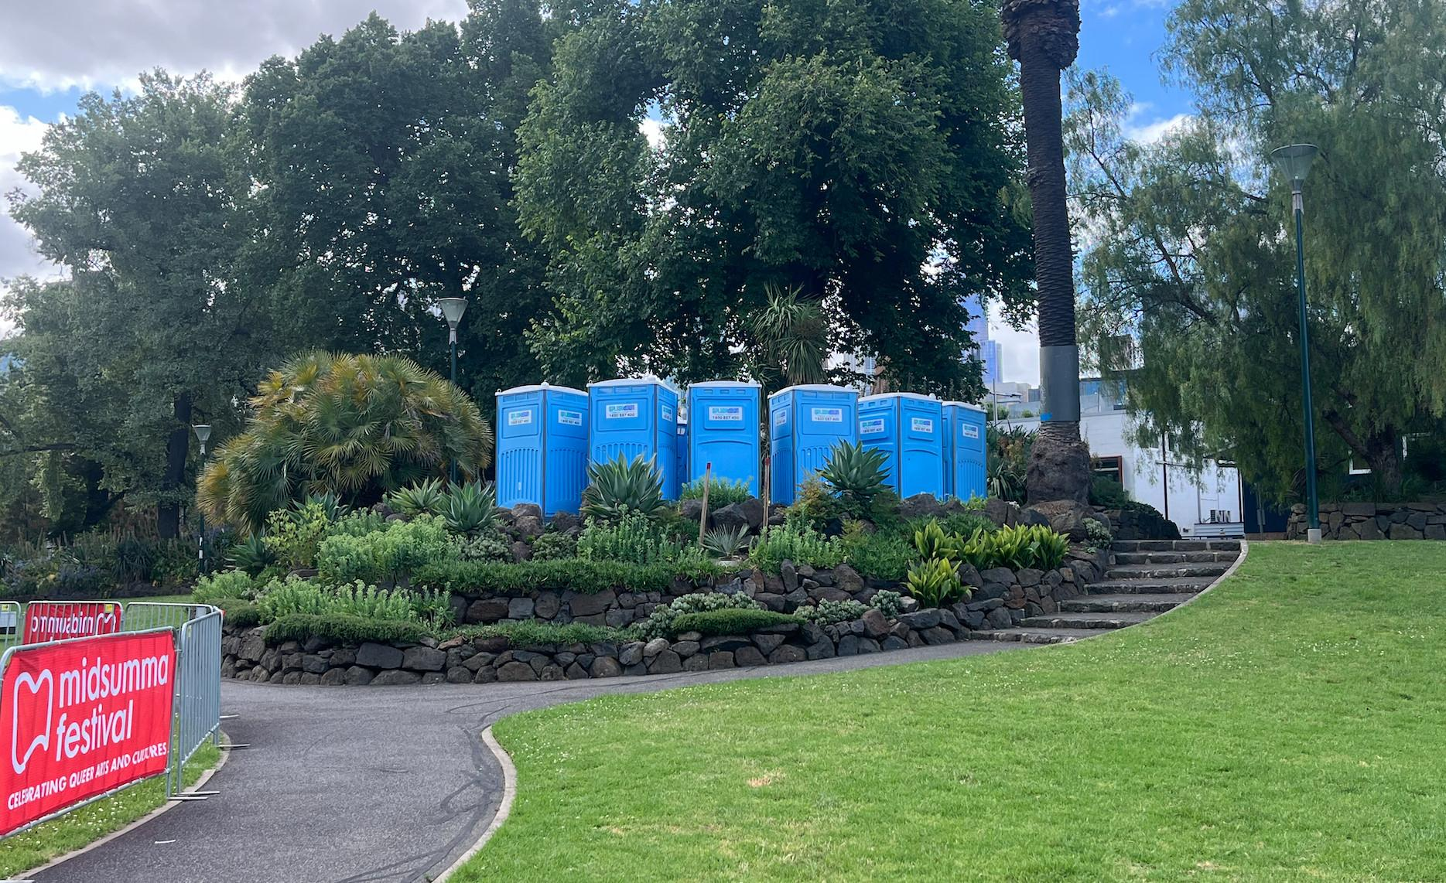

Image Description: A group of blue portable toilets and a decorative gardening arrangement.

If you are facing the Main Stage and the river, the Picnic Stage is located approximately 400 metres to your right.
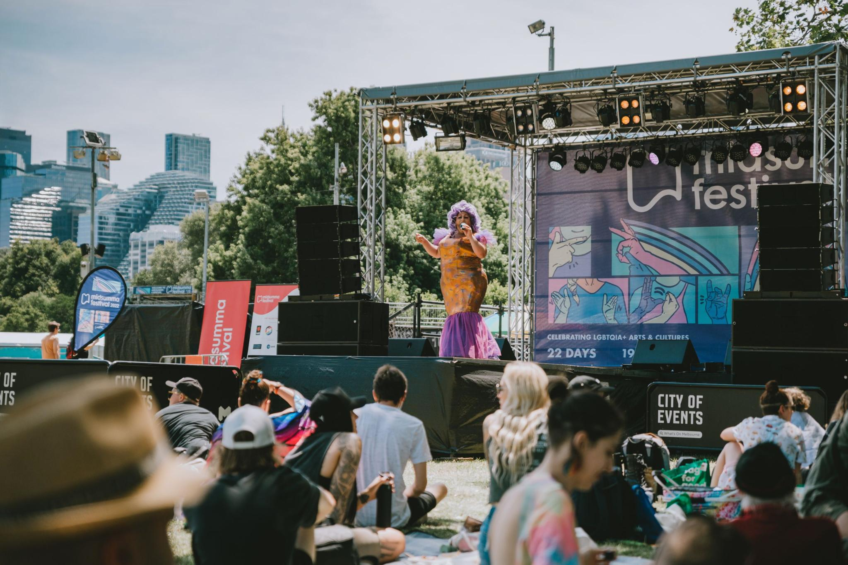
Image Description: A Drag Queen performing on a small stage, with people sitting down watching.
Image Credit: Nikki Russian – Midsumma Carnival 2022

Food trucks are available onsite where you can buy food. You can also bring your own food if you want to. Please don’t bring any glass containers.

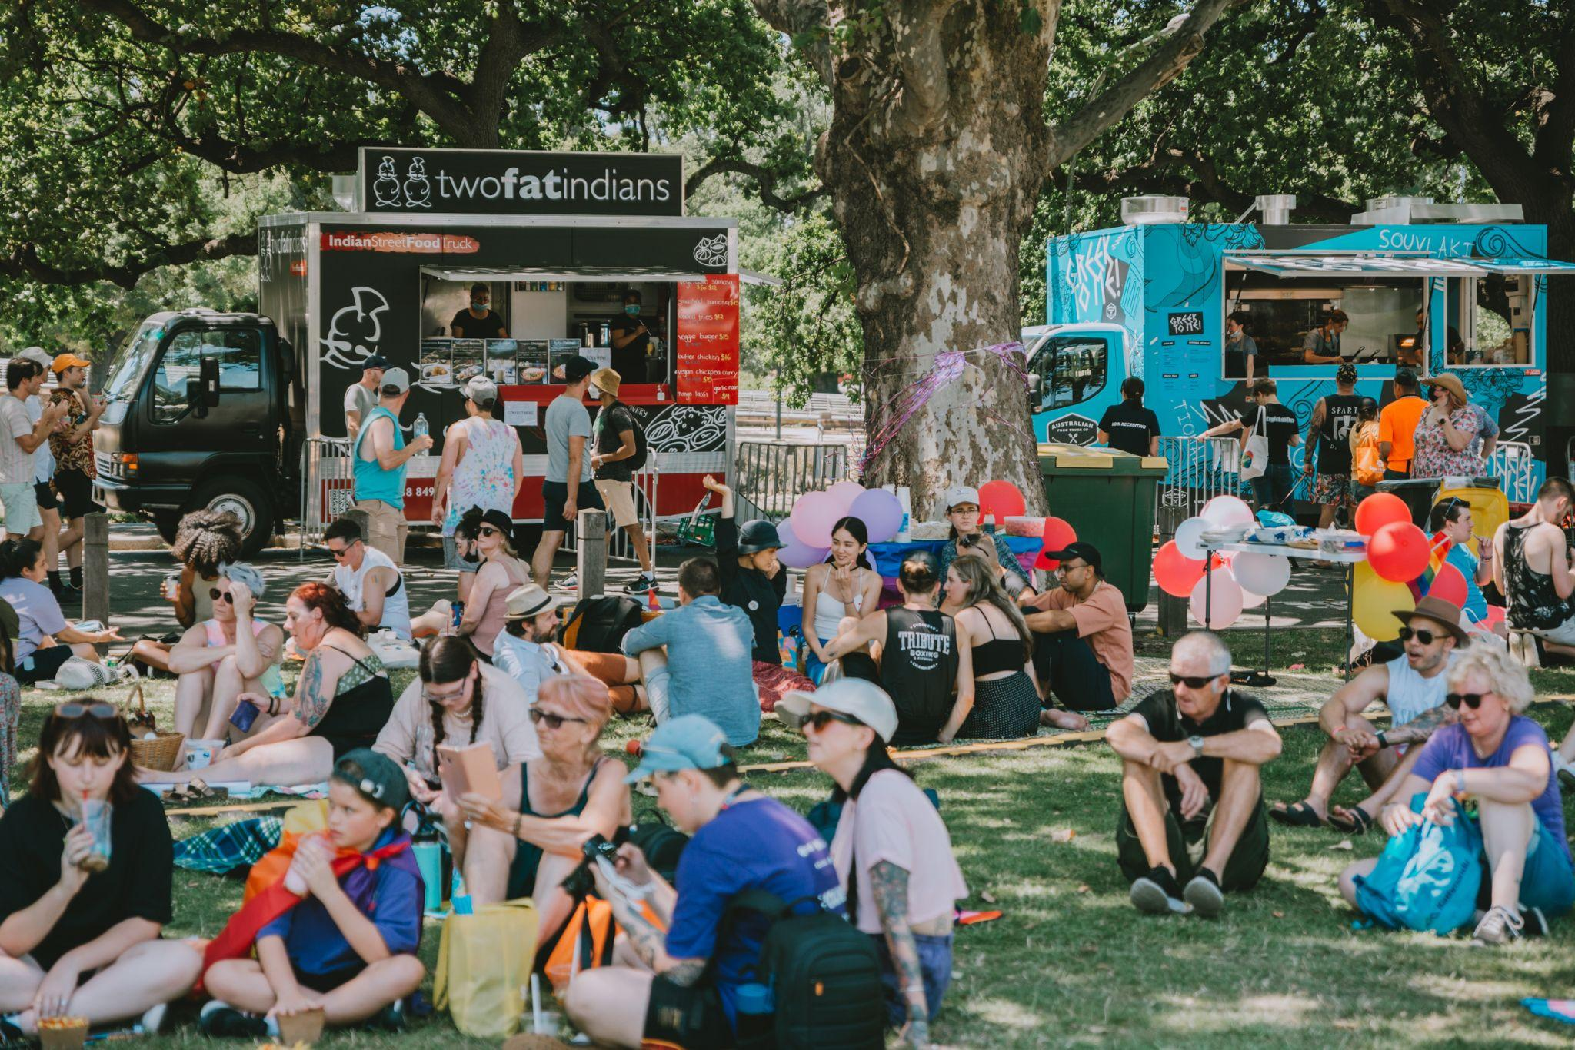

Image Description: People are sitting on the grass eating and drinking. In the background, there are food trucks lined up along the edge of the curb. Image Credit: Em Daniels – Midsumma Carnival 2022

To the right of the Picnic Stage precinct is a toilet block and a free water station.
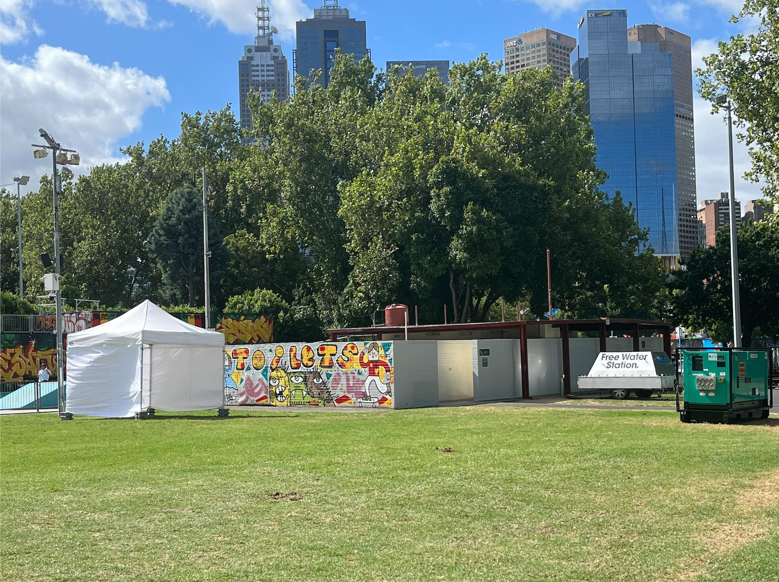
Image Description: A toilet block with colourful artwork on it, a water station and a white marquee.
There are lots of free water stations around the site.
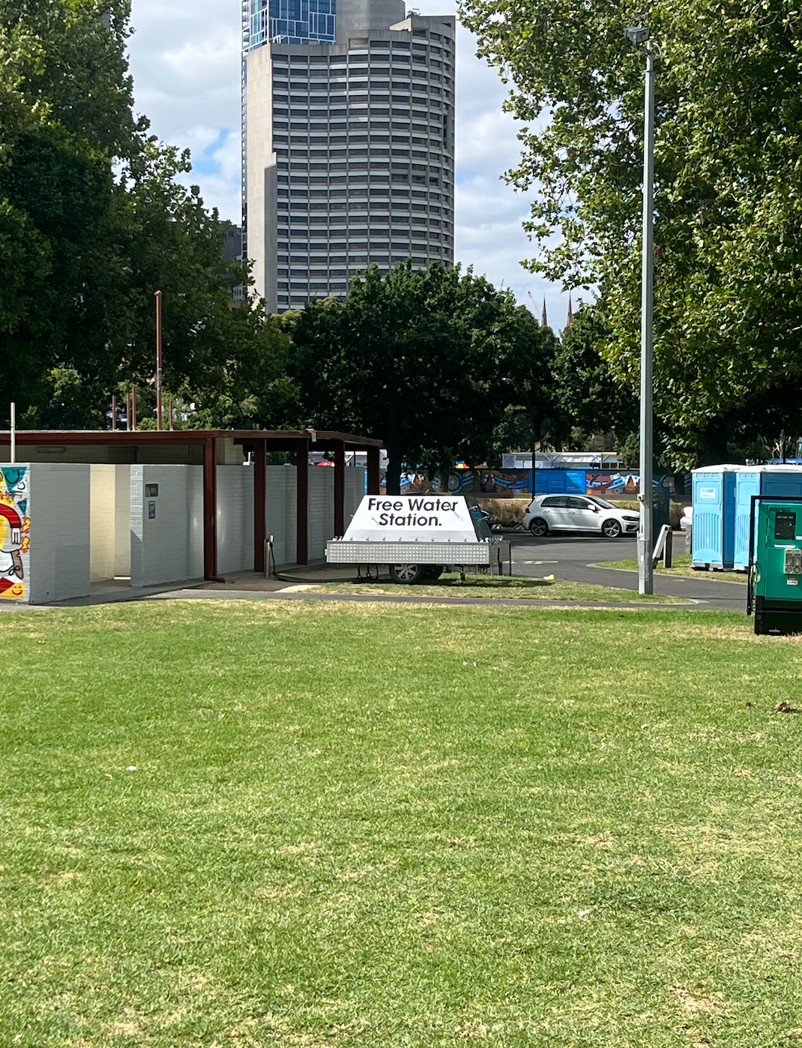

Image Description: Free Water Station situated near the toilet block near main stage surrounded by grass.
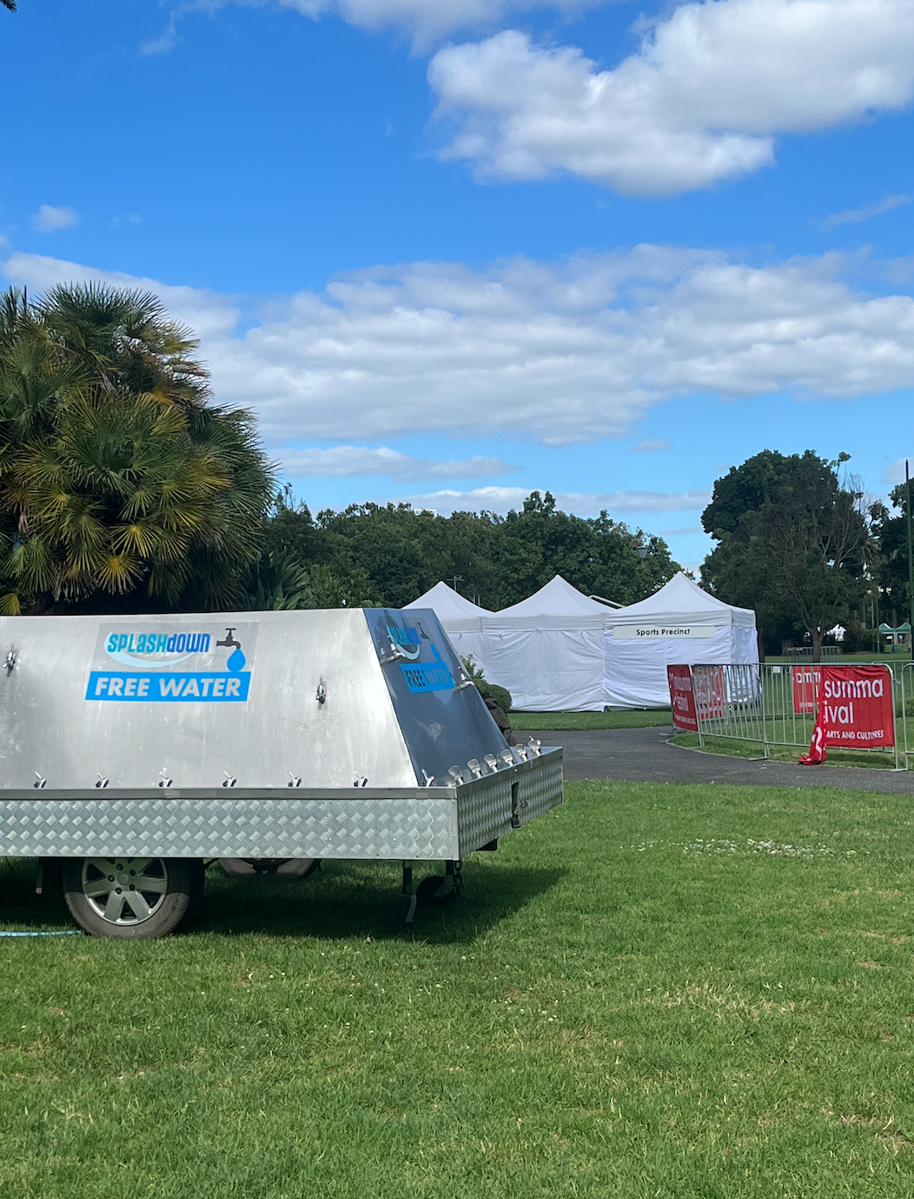
Image Description: Free Water Station with the Sports Precinct marquees in the background, surrounded by grass.

Sensory Information:

Temperature: It will be very hot, with not much shade.

Noise: There will be lots of loud noises coming from multiple points at the same time. There will be loud speakers at each stage, and some people bring their own personal speakers to play their own music.

Quiet Area:
Midsumma Carnival is a high sensory environment which means it is impossible to provide a suitable environment for sensory breaks. The quietest area is along Alexandra Parade, which is along the southern edge of the site. There are trees here that might provide some shade.

Stimming:
Stimming is welcomed and celebrated. We want you to feel like you can be yourself. Midsumma Carnival is a relaxed and inclusive social environment that is attended by diverse communities.

Further assistance:
On the day of Carnival, you can text or call Midsumma’s access hotline if you want information or assistance, or if you have questions. The phone number is 0437 557 109.

Before event day, you can email admin@midsumma.org.au or call 9296 6600 if you have any questions or feedback.

